Please read these Rules and Instructions before building your car.

PINEWOOD DERBY RULES
PARENT CLARIFICATION AND SUPPLEMENT SHEET

The following instructions and specifications have been adopted to avoid disqualifications and disappointment to Scouts participating in the Northern Lights Derby. Cars should be built by your Girl Scout with some adult guidance.

Trophies are awarded for first, second, and third place winners in each division. Trophies are also awarded for cars that do not run fast but show a girl has worked diligently on her car. These are chosen by a panel of judges.

1. Width: The overall width of the car may not exceed 2 ¾ inches. The inside wheel width must be no less than 1 5/8 inches so the car will clear the guide strips on the track. The guide strips are 1 ½ inches wide and are ¼ inch thick.

2. Length: The overall length of the car shall not exceed 7 inches. In some kits the original block may be slightly longer. It is best to remove 1/8 inch or so from the block before beginning to build the car.

3. Clearance: The bottom of the completed car must clear a flat surface by at least 3/8 inch. Do not shape the front of the car to a sharp point or allow the front to be higher than 1 inch above a flat surface or the car may override the starting pin on the track. If the car is shaped so that it will not sit against the starting pin race officials may run the car backward for race day.
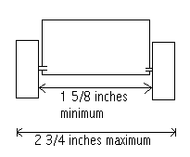

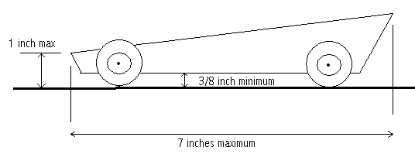

4. Weight: The weight of the finished car may not exceed 5 ounces or 142 grams. No loose material or sliding weights are allowed in the car. The car body may be hollowed out and built up to the maximum weight by the use of wood or metal only. If the car is built up with wood or metal, it must be securely built into the body. The original block of wood or an official replacement by the race officials must be used. If replacement parts are needed the race officials can help you get them. Do not attach weights to the outside bottom of the car because they may drag on the track guide strip.

5. Wheels and Axels: Wheels and axles (plated pins) that are supplied in the official Pinewood Derby Car Kit must be used. There are official pinewood derby wheels available in colors other than black that may be used. They can be purchased at the scout shop. All wheels must say BSA Pinewood Derby on them to be considered legal and official. NO SUBSTITUTIONS ARE ALLOWED. Replacements are available from the race officials. Wheel bearings, bushings, or washers are not allowed. Axle supports or other holding devices are prohibited. The car wheel base (position of the wheels along the base of the body) may be altered as long as the overall length specifications of the car is not exceeded. Removal of the seam on the wheels is allowed, but NO OTHER CHANGES to the general shape of the wheel are allowed (i.e. tapering, grooving, ridging, etc, that changes the contact of the wheel to the track surface).

6. Lubricants: The recommended wheel and axle lubricant is dry, powdered graphite although any lubricant may be used. Spray, liquid oils, or silicones may soften the plastic wheel and make the car slower.

7. Springing: The car shall not have any type of suspension springs.

8. Attachments: The car must be free wheeling with no starting devices.

9. Details: Details such as steering wheel, driver, motor (non-functional), interior details, fins and spoilers are permissible as long as these additions so not cause the car to exceed maximum width, length, or weight specifications.

10. Inspection: Each car must pass inspection by the official inspection committee before it may compete. The inspectors may disqualify cars from competition that do not meet the official specifications. If, at registration, a car does not pass inspection, the owner will be informed of the reason for failure, and will be given time within the official weigh-in time period to make the adjustment. Any race judge, starter, or other race official may question any car entered and bring it to the attention of the Inspection Committee.
Taking The Mystery Out Of Winning Design

The following are tips on designing a winning Girl Scout Derby car.

- Follow the rules outlined by the Northern Lights Derby Committee. All your work would be for naught if you are disqualified.
- Wheel alignment is very critical. Check the grooves in the block of wood to ensure that each is at a perfect 90º angle to the car body. True alignment will allow the car to track straight and eliminate the friction caused by rubbing the track guide. If you change the wheel base length, drill the pilot holes prior to cutting the block down. You will have a true edge to work from.
- Keep the center of gravity of the car as low as possible. This prevents swaying of the car as it proceeds down the track. The rule is the lower the center of gravity the better.
- Burrs should be removed from the axel. With adult supervision place the axel pin in a stationary electric drill. With a metal file remove the stamping marks on the shaft. After removal of the burrs sand the axel with 600 grit sandpaper but only the area that the wheel will ride. As a final step, polish the axel with wet pumice. Place the wet pumice on your finger and hold it on the spinning pin until the sanding marks are removed.
- If possible cement the axel in place allowing no cement to touch the wheel or exposed axel. Loose wheels will rattle and cause more friction.
- Wheel lubrication is critical. Dry lubricant is best. The wheel must have access from both sides to ensure proper lubrication. The original slots cut in the block will allow for access if you do not fill in the slot with wood filler. If you change the wheel base length you will have to cut new slots to allow access to the inner side of the wheel.
- Remember not only does the fastest car win but trophies are also given for the best paint, most original, best wipeout, classical Girl Scout design, etc.
- Have fun!

